E6225 Assignment 2
All the assignment must submitted by
Due: Saturday, week 10, 16/10/2021
Format: The solution must be submitted in word document by e-mail
Continious Assignment 2
Consider a Consider a 3×3 process given by Orgunnaike and Ray (1979); the transfer function matrix is obtained by empirical modeling technique as:
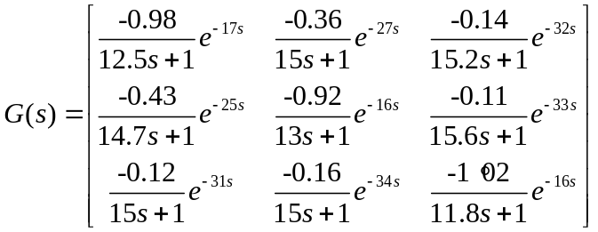
Try to design following controllers using ETF based methods
- Decentralized control
- Spases control
- Decoupling control
Compare the performance with the control system based on classical decentralized BLT control method by simulating the closed-loop performances for step response R₁(t)=1 for t>0, R₂(t)=1 for t>50 and R₃(t)=1 for t>100, respectively. (try to adjusting the the simulation time frame if the simulation horizens are not suitable).

